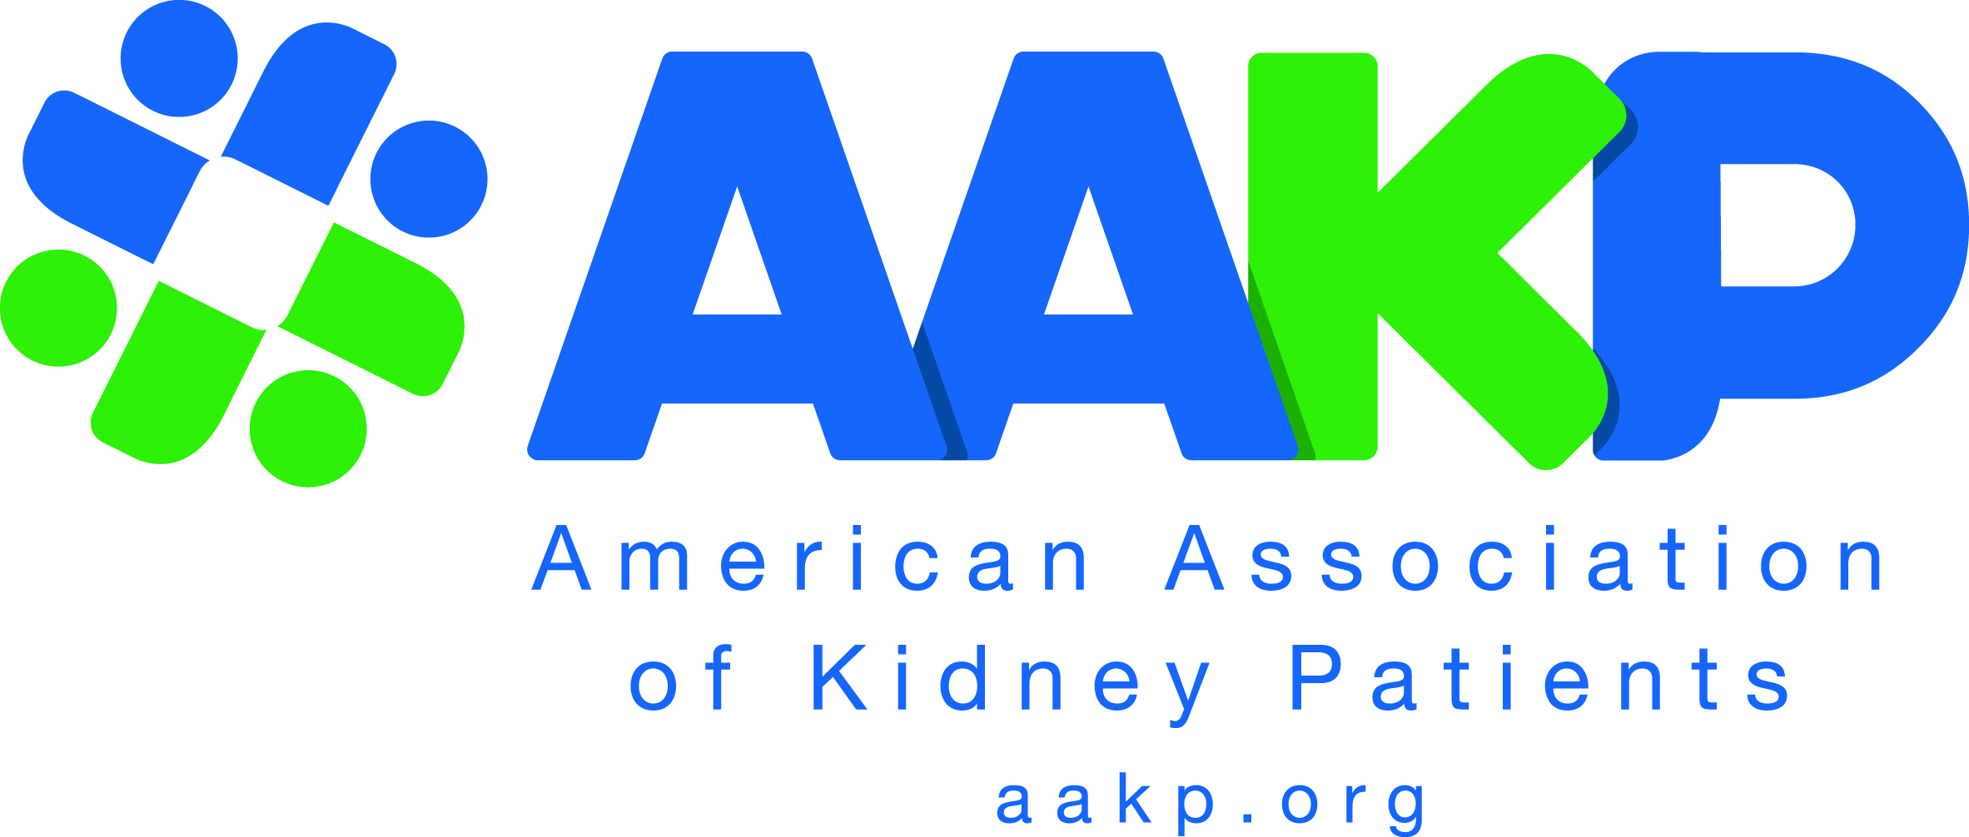
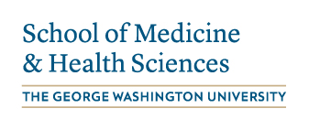

FOR IMMEDIATE RELEASE MEDIA CONTACT:

July 22, 2020 Jennifer Duplessie

Marketing & Communications Manager

jduplessie@aakp.org

(813) 400-2394

GLOBAL SUMMIT ON KIDNEY DISEASE INNOVATION AND CHOICE ENGAGES 70 COUNTRIES

COVID-19, Artificial Intelligence, New Implantable Kidneys, Clinical Trials, Precision Medicine

WASHINGTON, D.C. – The American Association of Kidney Patients (AAKP), the largest independent kidney patient organization in the USA, and strategic partner George Washington University (GW) School of Medicine & Health Sciences (SMHS) shattered their virtual engagement record with their second annual Global Summit, “Global Kidney Innovations – Expanding Patient Choices & Outcomes,” hosted July 16-17, 2020. The Global Kidney Innovations Summit has become the world’s largest patient-led kidney innovation conference.

The Summit engaged participants in over 70 countries and included over 20 special medical and patient expert sessions on: COVID-19 impacts on the kidney and kidney patients; artificial intelligence and early disease diagnosis; greater diversity in clinical trials; precision medicine; genetic conditions such as APOL1; wearable and artificial implantable devices; and advancements in home dialysis care. Tens of thousands of patients, clinical trial experts, pharmaceutical researchers, medical professionals, and policy leaders worldwide participated in the virtual Summit.

The Summit is part of AAKP’s Decade of the Kidney™, a strategic ten-year global innovation and collaborative initiative announced last year upon the signing of the historic bipartisan White House Executive Order on Advancing American Kidney Health. AAKP is fully committed to extending the lives of kidney patients through breakthrough technologies and scalable solutions that transcend status quo kidney care, especially outdated dialysis devices.

The meeting was opened by Dr. Griffin Rodgers, Director of the National Institute of Diabetes and Digestive and Kidney Diseases (NIDDK) and Chief of the Molecular and Clinical Hematology Branch at the U.S. National Institutes of Health (NIH). Dr. Rodgers is an international voice for patient inclusion in research and innovation, a research investigator, and is widely recognized for his contributions to the development of hydroxyurea, the first effective and FDA-approved therapy for sickle cell anemia. Dr. Rodgers is the recipient of the 2018 President’s Medal from the American Society of Nephrology (ASN) and a member of the American Board of Internal Medicine (ABIM) Board of Directors. Watch Dr. Rodgers’ remarks during the Global Summit.

AAKP President Richard Knight, a 14-year kidney transplant recipient, stated, “Kidney disease is a devastating disease that is rapidly expanding and negatively impacting patients, families, and economies throughout the world. Future innovations in kidney medicine depend upon greater patient engagement through fully inclusive clinical trials and research, and the GW School of Medicine & Health Sciences is a global leader in this field. I thank Dean Dr. Barbara Bass and Dr. Dominic Raj for their respect for patients and their efforts to unite patients and clinicians in the fight against all kidney diseases.” Knight serves on the NIH/NIDDK Advisory Council, is Co-Chair of the Strategic Plan Stakeholder Engagement Subgroup, and Co-Chair of the Community Engagement Committee for the Kidney Precision Medicine Project (KPMP). Knight is a nationally known kidney advocacy leader.

Dr. Dominic Raj, Co-Chair of the Global Summit and Professor of Medicine and Chief of the Division of Kidney Diseases and Hypertension for GW SMHS, stated, “Excellence is never an accident, but a mark of persistence and teamwork. Two great institutions with a synergistic goal partnered to take this meeting to the Summit, powered by the motivating spirit of kidney patients. This year’s Summit showcased not only the dire need for innovative discoveries and patient engagement, but also the significant progress made in the global arena in the field of nephrology.” Under the leadership of Dr. Raj, the GW SMHS Division of Kidney Diseases and Hypertension has been ranked as High Performing by US News and World Report for the past four years.
Paul T. Conway, Co-Chair of the Global Summit and AAKP Chair of Policy and Global Affairs, said, “AAKP and our friend Dr. Dominic Raj designed the Global Summit on Kidney Innovations to be a distinct international event aimed at accelerating cooperation among patients, researchers, clinicians, and policy professionals. Kidney patient consumers worldwide demand far greater care choice and are well aware of the unique value their patient preference information has among innovation leaders driving the next generation of diagnostics, devices, and biologics. AAKP is prepared to work with patients worldwide to defend and advance the ideas of courageous innovation leaders through regulatory, legislative, and payment processes to solve the problem of kidney disease.” Conway is a 23-year kidney transplant recipient and a former home peritoneal dialysis patient. He serves on the NIH/NIDDK External Expert Panel for the KPMP, is a member of the ABIM Nephrology Specialty Board, and a Patient Voice Editor for The Clinical Journal of the American Society of Nephrology (CJASN).
Knight and Conway are recipients of the 2017 ASN President’s Medal. During the Global Summit, AAKP announced a strategic partnership with the Renal Patient Support Group (RPSG), a United Kingdom (UK) international evidence-based patient group. The two organizations are committed to accelerating links among kidney patients worldwide to elevate patient insights among an international network of researchers, clinical trial experts, innovators, companies, and government leaders. This ground-breaking announcement is the first of its kind in the kidney patient community and signals widening support for an International Kidney Consortium.

All 2020 Global Summit presentations are now available OnDemand and will continue to reach tens of thousands of additional viewers across the world to increase the AAKP and GW SMHS reach of this year’s Global Summit content. The Inaugural AAKP/GW event in 2019 engaged just over 50 countries and a combined in-person and worldwide audience exceeding 20,000.

AAKP and GW SMHS thanks its 2020 Global Summit sponsors: Amgen, Inc.; CareDx, Inc.; Natera; Eurofins Transplant Genomics; Outset Medical; and Retrophin. Information on the 2021 Global Summit will be listed at https://aakp.org/programs-and-events/2nd-annual-global-summit-global-kidney-innovations-expanding-patient-choices-outcomes/ as it becomes available.

###

About the American Association of Kidney Patients (AAKP): AAKP is among the strongest global advocates for kidney patient consumer care choice and treatment innovation. From 1969-1973, AAKP patients led the effort in the U.S. Congress, alongside senior White House officials, to establish the End Stage Renal Disease Program, which has saved over a million lives through modern dialysis coverage. Since 2018, AAKP has conducted the largest virtual kidney voter registration drive in America, the “I am a Kidney Voter” campaign, which has registered patients in every state. For more information, visit www.aakp.org. Follow AAKP on social media: Facebook @kidneypatient and Twitter @kidneypatients.

About the GW School of Medicine and Health Sciences: Founded in 1824, the GW School of Medicine and Health Sciences (SMHS) was the first medical school in the nation’s capital and is the 11th oldest in the country. Working together in our nation’s capital, with integrity and resolve, the GW SMHS is committed to improving the health and well-being of our local, national, and global communities. Visit its website at smhs.gwu.edu.

